7. Project Documentation Phase
Project: Implement Client Script & UI Policy (ServiceNow)

Phase Objective
The important implementation details are organized for project reporting. The screenshots record the configured fields, rules, scripts, and form states so that the completed work can be explained and reviewed later.

Activities Covered
- Capture important implementation screens.
- Record configuration and result evidence.
- Organize screenshots for project explanation and review.

Screenshots from the Project Video
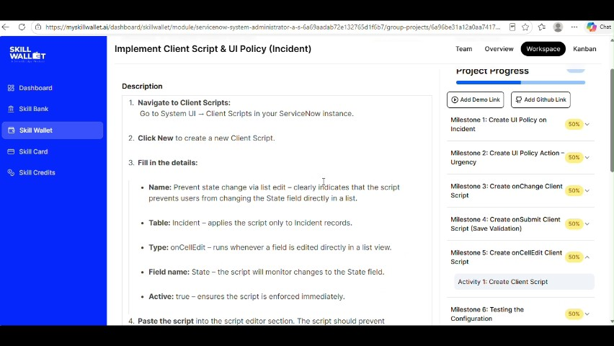
Figure 1: Project video screen at approximately 360 seconds.
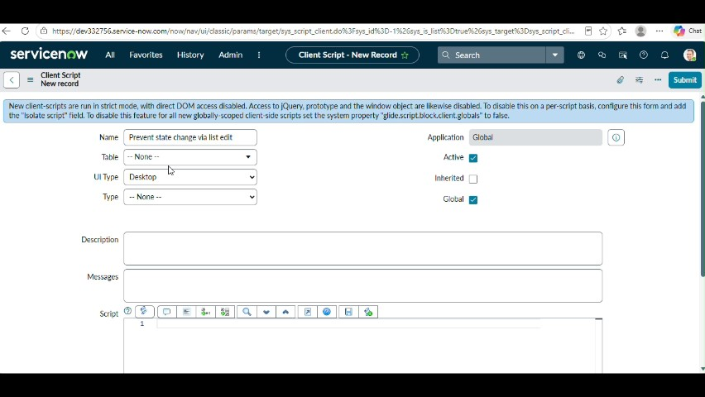
Figure 2: Project video screen at approximately 378 seconds.
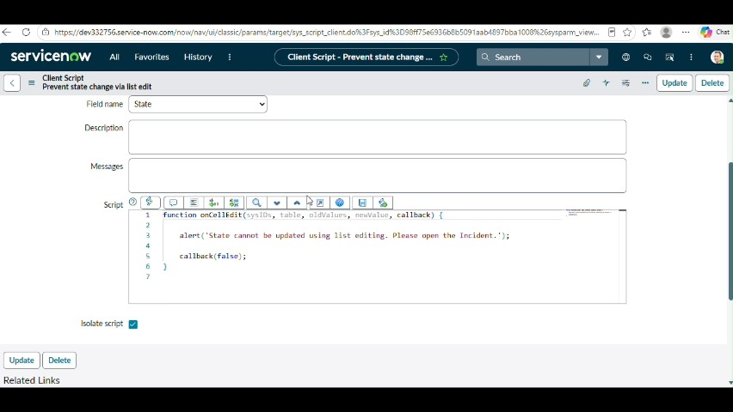
Figure 3: Project video screen at approximately 396 seconds.
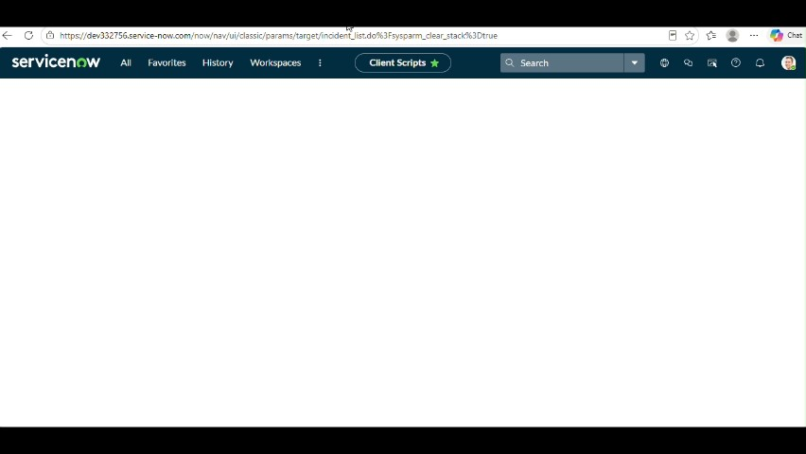
Figure 4: Project video screen at approximately 414 seconds.
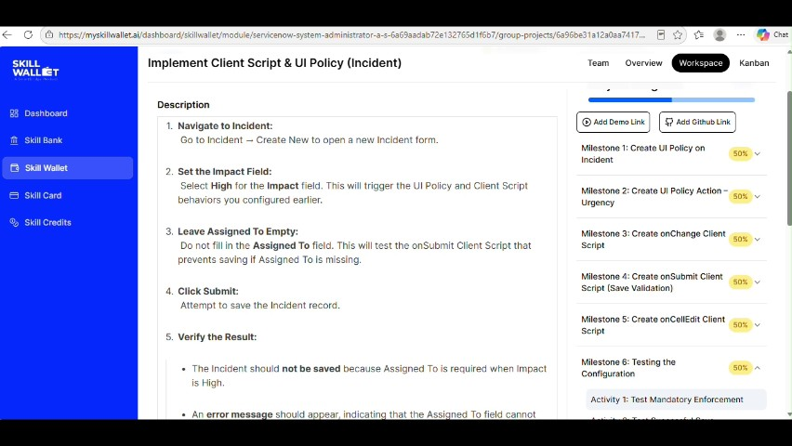
Figure 5: Project video screen at approximately 432 seconds.

Phase Outcome
The important project evidence is organized so the implementation can be explained and reviewed.
Prepared from the supplied project demonstration video

